CSE 595 Independent Study

Graph Theory

Week 3

California State University - San Bernardino

Richard Vargas

Supervisor – Dr Owen Murphy

Chapter 1 Problem 53 (Multigraphs)



1. This sequence is not capable of a multigraph because of Corollary 1.5 [1] which states

*Every graph has an even number of odd vertices*.

It is, however, capable of a pseudograph, where a loop (an edge which is connected to the same node) exists.

1. This sequence also contradicts the Corollary 1.5 from part a, and therefore a multigraph does not exist.
2. 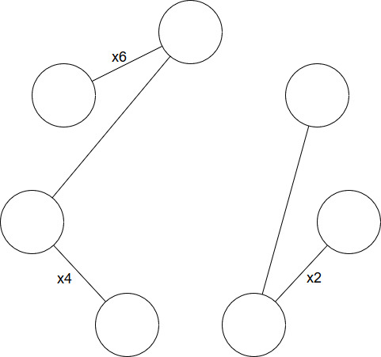 The following does exist as a multigraph, shown below.

Chapter 2 Problem 3 (Connected Graphs)



1. Let $u,v$ be vertices in graph $G_{1},G_{2}$ respectively. A matrix is equal iff they have the same dimensionality and the corresponding elements are the same. Therefore, if $A_{1}=A_{2}$ then these graphs must be isomorphic with each vertex $v_{i,j}∈G_{1}$ having the same exact adjacent vertices as its counterpart $u_{i,j}∈G_{2}$. Hence, if $A_{1}=A_{2},$ then $G_{1}≅ G_{2}$ is true. $∎$
2. Assume that this statement is true. Therefore, there should not exists two graphs $G_{1},G_{2}$ such that $A_{1}≠A_{2}$ and $G_{1}≅ G_{2}$. Examining the following two adjacency matrices $A_{1},A_{2}$

$$A_{1}=\left[\begin{matrix}0 & 1 & 0 \\ 1 & 0 & 0 \\ 0 & 0 & 0\end{matrix}\right], A_{2}=\left[\begin{matrix}0 & 0 & 1 \\ 0 & 0 & 0 \\ 1 & 0 & 0\end{matrix}\right]$$

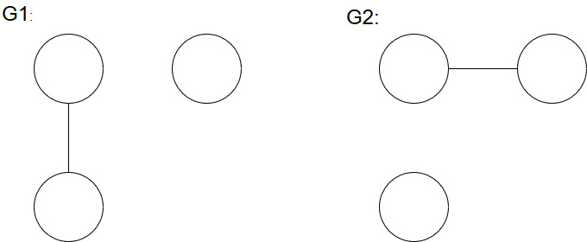 Obviously, these matrices are not equal, however the graphs are isomorphic, as seen below.

Thus, the statement if $A_{1}≠A_{2}$, then $G_{1}≇ G_{2}$ is not true. $∎$

Chapter 2 Problem 5 (Connected Graphs)



The adjacency matrix of graph *G* is,

$$A=\left[\begin{matrix}\begin{matrix}0 \\ 1 \\ \begin{matrix}1 \\ 0\end{matrix}\end{matrix} & \begin{matrix}1 \\ 0 \\ \begin{matrix}1 \\ 1\end{matrix}\end{matrix} & \begin{matrix}\begin{matrix}1 \\ 1 \\ \begin{matrix}0 \\ 1\end{matrix}\end{matrix} & \begin{matrix}0 \\ 1 \\ \begin{matrix}1 \\ 0\end{matrix}\end{matrix}\end{matrix}\end{matrix}\right]$$

The adjacency matrix of graph *G* with walk length 2 is,

$$A^{2}=\left[\begin{matrix}\begin{matrix}2 \\ 1 \\ \begin{matrix}1 \\ 2\end{matrix}\end{matrix} & \begin{matrix}1 \\ 3 \\ \begin{matrix}2 \\ 1\end{matrix}\end{matrix} & \begin{matrix}\begin{matrix}1 \\ 2 \\ \begin{matrix}3 \\ 1\end{matrix}\end{matrix} & \begin{matrix}2 \\ 1 \\ \begin{matrix}1 \\ 2\end{matrix}\end{matrix}\end{matrix}\end{matrix}\right]$$

The adjacency matrix of graph *G* with walk length 3 is,

$$A^{3}=\left[\begin{matrix}\begin{matrix}2 \\ 4 \\ \begin{matrix}4 \\ 2\end{matrix}\end{matrix} & \begin{matrix}4 \\ 4 \\ \begin{matrix}3 \\ 4\end{matrix}\end{matrix} & \begin{matrix}\begin{matrix}4 \\ 3 \\ \begin{matrix}4 \\ 4\end{matrix}\end{matrix} & \begin{matrix}2 \\ 4 \\ \begin{matrix}4 \\ 2\end{matrix}\end{matrix}\end{matrix}\end{matrix}\right]$$

Chapter 2 Problem 7 (Connected Graphs)



Upon trying to solve this problem and using the solutions and hints portion in Chartrand [1], it was determined that the matrix $A^{3}$ is not actually the power of matrix $A$. The solution, according the text $V\left(G\right)=\{v_{1},v_{2},v_{3},v_{4},v_{5}\}$ and $E\left(G\right)=\{v_{1}v_{2},v_{1}v_{3},v_{2}v_{3},v_{3}v_{4},v_{4}v_{5}\}$. This graph has the corresponding adjacency matrix,

$$A=\left[\begin{matrix}\begin{aligned}0 \\ 1 \\ \begin{aligned}1 \\ \begin{aligned}0 \\ 0\end{aligned}\end{aligned}\end{aligned} & \begin{aligned}1 \\ 0 \\ \begin{aligned}1 \\ \begin{aligned}0 \\ 0\end{aligned}\end{aligned}\end{aligned} & \begin{matrix}\begin{aligned}1 \\ 1 \\ \begin{aligned}0 \\ \begin{aligned}1 \\ 0\end{aligned}\end{aligned}\end{aligned} & \begin{aligned}0 \\ 0 \\ \begin{aligned}1 \\ \begin{aligned}0 \\ 1\end{aligned}\end{aligned}\end{aligned} & \begin{aligned}0 \\ 0 \\ \begin{aligned}0 \\ \begin{aligned}1 \\ 0\end{aligned}\end{aligned}\end{aligned}\end{matrix}\end{matrix}\right]$$

Multiplying $A×A$ gives the correct $A^{2}$ matrix. Multiplying $A^{2}×A$ does not get the $A^{3}$ matrix given in the problem. Instead, the matrix $A^{3}$ is

$$A^{3}=\left[\begin{matrix}\begin{aligned}2 \\ 3 \\ \begin{aligned}4 \\ \begin{aligned}1 \\ 1\end{aligned}\end{aligned}\end{aligned} & \begin{aligned}3 \\ 2 \\ \begin{aligned}4 \\ \begin{aligned}1 \\ 1\end{aligned}\end{aligned}\end{aligned} & \begin{matrix}\begin{aligned}4 \\ 4 \\ \begin{aligned}2 \\ \begin{aligned}4 \\ 0\end{aligned}\end{aligned}\end{aligned} & \begin{aligned}1 \\ 1 \\ \begin{aligned}4 \\ \begin{aligned}0 \\ 2\end{aligned}\end{aligned}\end{aligned} & \begin{aligned}1 \\ 1 \\ \begin{aligned}0 \\ \begin{aligned}2 \\ 0\end{aligned}\end{aligned}\end{aligned}\end{matrix}\end{matrix}\right]$$

I have verified that the $A^{3}$ would not be correct, as performing $A^{-2}×A^{3}≠A$ and in fact if this operation is performed, non-integer numbers are achieved.

Problem 25 (Distance in Graphs)



First reduce the problem algebraically

$$d\left(u,v\right)+d\left(u,w\right)+d\left(v,w\right)≥2d(u,w)$$

$$d\left(u,v\right)+d\left(v,w\right)≥d(u,w)$$

Thus, based on the triangle inequality in Chartrand [1] which states

$d\left(u,v\right)+d\left(v,w\right)≥d(u,w)$*for all $u,v,w∈V(G)$*

However, for the sake of further examination of the problem,

If we assume the case $u=v$

$$d\left(u,v\right)=0→d\left(u,v\right)+d\left(v,w\right)=d\left(u,w\right)$$

$$∴d\left(u,w\right)=d(u,w)$$

All other cases if it obvious to see that if the path $u-v∈u-w$ geodesic then,

$$d\left(u,v\right)+d\left(v,w\right)=d\left(u,w\right)$$

Otherwise,

$$d\left(u,v\right)>0→d\left(u,v\right)+d\left(v,w\right)>d\left(u,w\right)∎$$

Problem 31 (Distance in Graphs)



By definition of the radius and diameter of a graph, the following portion of the inequality,

$$a≤b$$

Is obviously true, so the other inequality to show is,

$$b≤2a$$

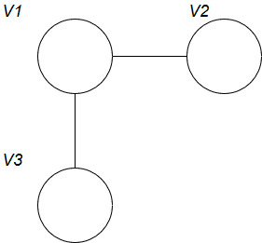Consider the following graph,

$$e\left(v_{1}\right)=1, e\left(v_{2}\right)=e\left(v_{3}\right)=2$$

Therefore,

$$Diam\left(G\right)=2, Rad\left(G\right)=1$$

Thus, a graph *G* with the property exists $a≤b≤2a$. $∎$

Works cited

“Connected Graphs and Digraphs.” *Graphs & Digraphs*, by Gary Chartrand et al., CRC Press, 2016, pp. 25–55.